Top of Form
Bottom of Form

THANJAVUR, May 20, 2010

Celebrities grace the Bhagavata Mela in Melattur
Special Correspondent
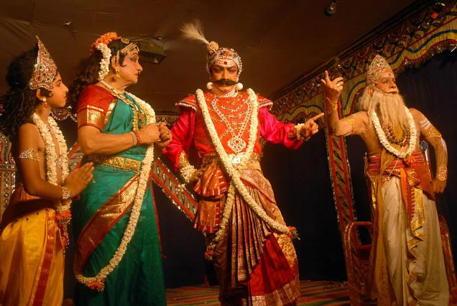
The Hindu Artistes performing at the Bhagavata Mela Natakam on 'Prahalada Charitam'. This is the 70th year of the Bhagavata Mela tradition as part of the Sri Narasimha Jayanthi in Melattur village near Thanjavur on Wednesday. Photo: M. Srinath
Come the month of May, it is time for the Bhagavata Mela at Melattur, a tiny village near Thanjavur.
This is the 70th year of the Bhagavata Mela Nataka Mahotsav organised by the Bhagavata Mela Natya Nataka Sangam. The festival has always commenced with the staging of the Prahalada Charitam ? a Bhagavata Mela Natakam at Varadaraja Perumal Sannidhi in Melattur on Wednesday.
Impressive
S. Natarajan, president and chairman of the Bhagavata Mela Natya Nataka Sangam, as usual, donned the role of Leelavathi and impressed the audience with his excellent performance.
Venkatasubramanian alias Ganesh donned the role of Narasimha with the age-old Narasimha mask on his face and terrified the audience with his electrifying performance.
Powerful mask
The mask is very sacred for the artistes of the Bhagavata Mela. It is said to have enormous powers.
According to Natarajan, the architect of the festival for the past 60 years, it is the mask and the spiritual power of the Lord that keeps him going.
The artistes, wherever they are, land in Melattur in summer to perform at the Bhagavata Mela. Natarajan, who works in Dubai, comes to Melattur to conduct the festival.
Honoured
This year's inauguration saw the presence of a group of celebrities. Padma Subramanyam, Chitra Visveswaran, Sudharani Raghupathy and Vijayantimala Bali, were present on stage and honoured Natarajan by presenting him a shawl.
Subramanyam said that the Bhagavata Mela was not for entertainment. ?It is an offering to the Lord. It is maintained in its pristine purity by the Nataka Sangam.? Others who attended the function include dancer/actor Swarnamalya and musicologist B.M. Sundaram.
According to Natarajan, the geat Bhagavata Mela tradition, a rare temple/theatre art in a unique blend of bhakti, music, dance and drama and is the only surviving link in the State that connects people to Sanskrit theatre.
The Natakams, composed by Melattur Venkatarama Sastry (1743-1809 A.D) are performed annually in adherence to the Natya veda in the sannidhi of Lord Sri Varadaraja, the presiding deity of Melattur village as part of Sri Narasimha Jayanthi Vasantotsav.
The festival, which began on Wednesday, concludes on May 27. Natakams Harischandra one, Harischandra two, and Harihara Leelavilasam will be staged during the festival. Bharatanatyam and Tamil opera Valli Thirumanam will also be staged. Starting at 9.30 p.m., the Natakams go on till late in the night.

